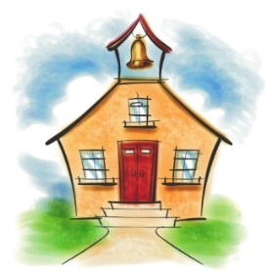

Miss Wilbanks
Kindergarten
August 15, 2014

Thank you for coming to “Curriculum Night” last night. We have a wonderful group of children and parents! Your support is appreciated! I enjoyed getting to know all of you last night. It is evident to see why we have such a SPECIAL group of children this year! :0) If you were unable to attend, I am sending home a packet of information for you to review and keep. Please be sure to sign and return the “marked” forms inside the folder if you have not already done so. Also, you may review the information presented at “Curriculum Night” on our school website www.myduncancreek.com
go to “About Us” – “Staff” – “Kindergarten” – “Wilbanks” – “Website” - “Curriculum Night”
You will also find our sight words and weekly newsletter here as well.
Thank you! :0)

We will work on the following skills next week:
- identifying upper and lower case letters and sounds
- identifying common sight words
- shapes
- color words
- identifying and counting numbers 1 - 20

Homework:
“Mm Book”
Please look for Mm pictures, letters & words in magazines, printed from the computer, or you may choose to draw them. Please label each picture (5 or more). You may also write a sentence to go with each picture. Please turn in on Friday, August 22nd.
Optional Homework/ Challenge Homework: Please write a story about a mouse. :0)
Please send in on Friday, August 22nd .
***Homework continued from last week:
“Bb Book” & Homework Extension (Optional) – Please turn in when your child has completed this assignment. Thank you!

Important Information:
*The children may purchase ice cream starting in September. Our class will only purchase ice cream on Friday. You may send in $ 1.00 to purchase ice cream each Friday. Please note this is OPTIONAL. I will not be able to provide change for this, so please send in one dollar or send in exact change. Thank You!

Wish List:
Bags of candy for our treat box
Stickers and small toys for our treat box
Extra snacks
Large Package of Small Cups for the classroom

- PLEASE RETURN YOUR LIBRARY BOOKS ON MONDAY. Thank you! :0)

Have a wonderful weekend! Miss Wilbanks & Mrs. Heffner

