Dear Parents,
Fall conferences will be approaching soon. This year Early Release Conferences are scheduled for September 24th and 25th. Duncan Creek is pleased to again offer parents the opportunity to schedule teacher conferences online. This will allow parents to select times that are convenient, as well as coordinate multiple children’s conference times. Please refer to the following directions to schedule your time to meet and discuss your child’s progress.
- Go to myduncancreek.com/home.html and “click” on the Fall Conference link (available September 9th) under the “News Flash” section.
- Select your child’s teacher.
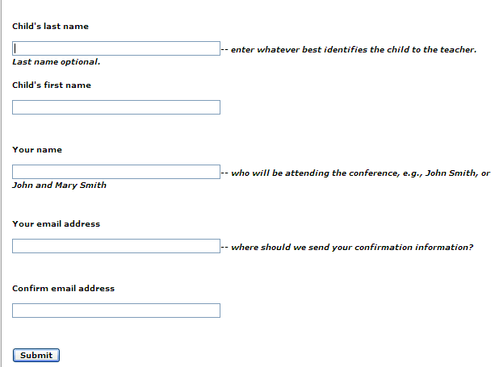
You will be required to provide a valid email address for access.
- Fill out the form and select submit.
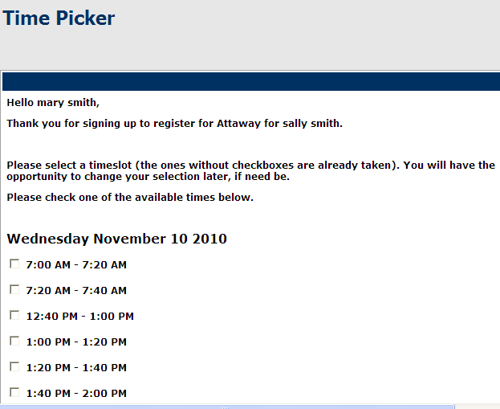
- You will then be sent an email with a link that will allow you to register for your conference time. Click the link and choose your time. IF YOU DO NOT GET AN EMAIL….CHECK YOUR SPAM/JUNK FOLDER.
IF you do NOT have internet access or an email address, please return the form below by September 9th. Your child’s teacher will contact you regarding a conference time.
Student Name ______________________ Teacher ____________________________

Preferred Time of Day: Morning Early Afternoon Late Afternoon

Preferred Day of Week: Wed Thurs

