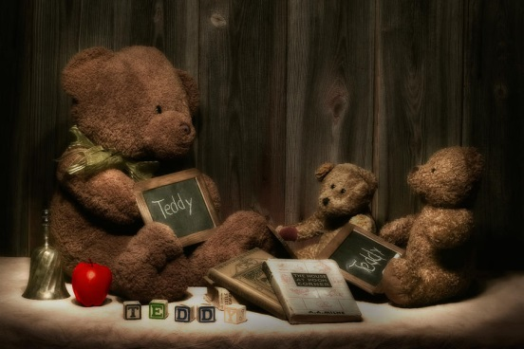

Miss Wilbanks
Kindergarten
October 31, 2014

Special thanks to ALL of our volunteers who volunteered their time on Thursday for our “Fall Festival” and to our parents who donated items to make this event possible for our children. Also, SPECIAL THANKS to our Room Mom, Vanessa Patterson, for organizing this event for our class. :0)
We sure enjoyed our “Character Dress Up Day!” The children were so excited to wear their costumes and share their books with each other. I am so PROUD of their hard work! :0)

We will continue to work on the following skills next week:
- letter/sound recognition & sounding out words
- sight words: the, and, to, see, you, it, like, me, for, go, play, yes, no, and color words
- identifying and writing common sight words: color words & yes, no, like, to, and my
- money – coin names and values
- recognizing and writing numbers to 30 & identifying a number between two given numbers (0 – 30)
- addition – adding numbers up to 10 (2 + 2 = 4)
- counting to 100, recognizing and writing numbers
Homework:
Write a scary story. Please write at least 3 sentences. Please use phonetic spelling and sight words. Please turn in on Friday.
*Please continue to read your take-home reading books and be sure to record it in your reading log.
Thank you! :0)

Please check our website for more information. Also, you may check my website by going to “About Us” – “Staff” – “Kindergarten” – “Wilbanks” – Website @ www.myduncancreek.com
Please be sure to check our school website for important information each week regarding important “school wide” events and activities. Thank you! :0)

SPECIALS:
Monday – Music
Tuesday – STEM
Wednesday – PE
Thursday – Art
Friday – Music
Have a wonderful weekend!!! :0)
Miss Wilbanks & Mrs. Heffner

